Beyond the Syllabus

A Bi-monthly Column by Anthony D. Fredericks, Ed.D.

The First Day; First Impressions
Every college student approaches each new course with trepidation and anxiety. If it is true that “first impressions are lasting impressions,” then it is equally true that we need to help our students get off on the right foot at the start of each new course. Indeed, the success students enjoy in your courses will often be determined by the impressions they take away from that all-important first class session.

You can alleviate many of their fears (as well as most of yours) by focusing on two basic concepts. While these are areas you need to focus on during the first day/first week of class, they are also important areas of concentration throughout the entire semester, too.

- Building a Community (student to student interaction)
- Building Rapport (professor to student interaction)

Building a Community
One of the most frequently used opening activities of the semester is to spend the first class going over the course syllabus. All of the requirements for the course are dutifully laid out, the assessment of students is spelled out in minute detail, and the procedures and practices of the course are systematically provided. Afterwards, the question is posed, “Are there any questions?” Hearing none, the instructor dismisses the class with a final comment, “See you next time.”

The problem with this opening is that an inappropriate message is sent to students. That message is, “The material is more important than you.” Students often walk away from these first sessions bewildered, dazed, and upset. They are certainly intimidated. Their first impression is that what they do is much more important than who they are.

On the other hand, professors who take time to establish a “community of learners” on that all-important first day will send a most powerful message to students. That is, the value of people is to be celebrated as much as the value of the material. Here are some opening day activities and ideas that will get your semester off to a positive start and establish your own “community of learners.”
- Students begin building a classroom community when they share common connections. Invite students to pair up with someone they don’t know. Ask the students to interview each other about the reasons why they are taking the course or their personal expectations for the course. After the interviews, invite each member of a pair to introduce her/his partner to the entire class, with reference to why they are taking the course. Keep the atmosphere casual and comment every so often on any similarities or differences.
- Divide the class into several random groups. Provide each group with a sheet of newsprint and several markers. Tell each of the groups that they (collectively) represent an incredible array of talents and experiences. Invite each group to compose a group resume. The resume should include any information that promotes the group as a whole. Each group may chose to include any of the following: educational background, knowledge about the discipline, hobbies, major accomplishments, travel, job experiences, etc. Invite each group to share their “resume” with the whole class.
- Schedule a class meeting or roundtable early in the course. This can be a circle of chairs or tables. Take time to talk about some of your expectations as well as some of the exciting learning opportunities you’ve planned. Invite students to share some of their fears or anxieties, too.

One impressive research study out of Harvard University concluded that for college students, “the emotional climate of the classroom is directly related to the attainment of academic excellence, however defined. Students feelings about what they will experience in class…cannot be divorced from what and how well they will learn.”

Building Rapport
A plethora of research has revealed that one of the most significant factors that ensures the success students experience in a course is the rapport established between the professor and themselves. On the other hand, professors who are arrogant, “stand-offish,” elitist or distant are those who create uncomfortable classroom environments – environments that impede the learning process and inhibit students’ engagement in the subject.

In my annual informal assessments of students, the following comments are those that are frequently proffered in response to the question, “What characteristics of an instructor help you learn best?” Here are the top eight responses (those ranked highest over each of the last five years):
  - respectful of students
  - approachability
  - caring
  - willing to help
  - open-minded
  - supportive
  - fairness
  - considerate
It’s interesting to note that none of the top eight responses have anything to do with knowledge of subject matter, number of books or articles published, tenure, rank, graduate institution attended, gender, or age. They all center around the interpersonal relationships between students and professors. In short, the rapport we establish with our students has more to do with their academic success than does the number of degrees we hold, the number of years we’ve been teaching, or our stature in the academic community.

Here are some first-day suggestions and activities that will help you establish a level of rapport with your students. As with the previous list, feel free to select those ideas with which you are most comfortable. By the same token, consider the inclusion (and extension) of these suggestions throughout the length of the semester.
- Take time during the first class to disclose some information about yourself that may not be evident to students. You might want to describe some of your experiences as a college student, particularly those related to the discipline you are now teaching. Tell students about your early years – where you grew up, schools attended, hobbies, interests, and places traveled. This opens the door to all sorts of conversations (and revelations) critical to building good relationships.
- Divide the class into several groups. Invite each group to decide on a series of three questions they would like to ask you (questions unrelated to course content or procedures). The questions may relate to your family life, background, education, political preferences, favorite restaurants, travel, or reading material. Invite students to record the questions on individual index cards. Collect the cards (this allows you to pre-screen the questions) and respond accordingly.
- Start off the first class by posting a philosophical statement on the chalkboard or whiteboard. This should be a statement that is reflective of your own personal philosophy. Here are some I have used:
  - “Imagination is more important than knowledge.” – Albert Einstein
  - “There is nothing more dangerous than a closed mind.”
  - “Education is a process, never a product.”
  - “I touch the future, I teach.” – Christa McAuliffe
  - “Education is not the filling of a pail, but the lighting of a fire.” – William Butler Yeats
Talk with students as to why that particular philosophical statement is reflective of your outlook on life or your outlook on teaching college. Then, invite students, either individually or in groups, to design their own philosophical statements.

The most frequently suggested tip shared by outstanding college teachers nationwide was that the time you take on the first day (or in the first week) to establish positive relationships between students and between your students and you will pay enormous dividends throughout the course. This is not wasted time!

_____________________

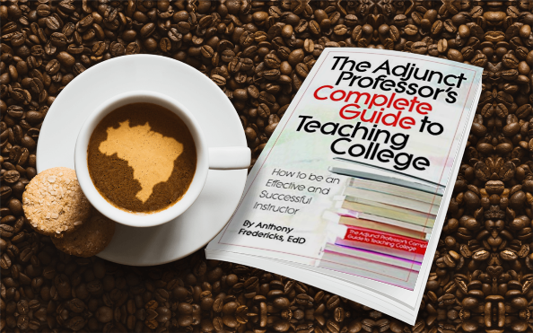
Dr. Anthony D. Fredericks is Professor Emeritus of Education at York College of Pennsylvania (and a former adjunct professor). He is an award-winning author of 175+ books, including The Adjunct Professor’s Complete Guide to Teaching College (“It literally had everything you could possibly want to know [and] is written in realistic and relatable terms!” (5-star review)

